Dear Mr. Tomlin,

For end users, like the East Baton Rouge Parish Library, the FusionBot site search engine subscription service is only available for purchase through the LOGIKA Corporation. Our Reseller Program is for web design firms, implementing on their customer's behalf, not for end users.

The library's website has already been developed and thus the service of one of our resellers is not needed, just the FusionBot search engine feature.
This subscription service can only be obtained (and renewed) directly through LOGIKA Corporation.

Your continued business is appreciated. Please let me know if you have any further questions.

Service is being provided for the subscription period of 11-22-2018 through 11-21-2019.

Regards,

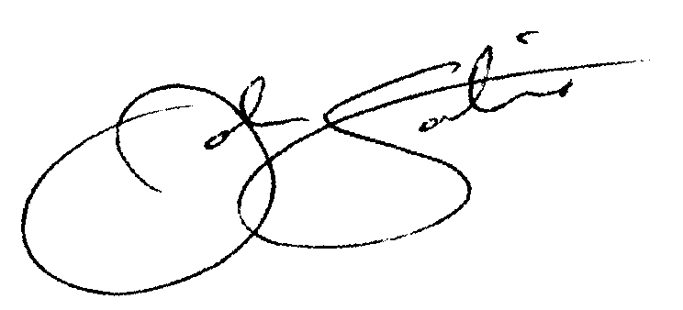

John Sortino
VP – Sales & Marketing
LOGIKA Corporation / FusionBot.com

